Supplementary Material

Area-selective deposition of germanium on patterned graphene/monolayer molybdenum disulfide stacks via dipole engineering
Yeonjoo Lee¹, Towfiq Ahmed², Xuejing Wang¹, Michael T. Pettes¹, Yeonhoo Kim³, Jeongwon Park⁴, Woo Seok Yang⁵, Kibum Kang⁴, Young Joon Hong⁶, Soyeong Kwon⁷, Jinkyoung Yoo^{1,*}

¹Center for Integrated Nanotechnologies, Los Alamos National Laboratory, Los Alamos, NM 87545, USA
²National Security Directorate, Pacific Northwest National Laboratory, Richland, WA 99354, USA
³Interdisciplinary Materials Measurement Institute, Korea Research Institute of Standards and Science, Daejeon 34133, Republic of Korea
⁴Department of Materials Science and Engineering, Korea Advanced Institute of Science and Technology (KAIST), 291 Daehak-ro, Yuseong-gu, Daejeon 34141, Republic of Korea
⁵Electronic Material and Device Research Center, Korea Electronics Technology Institute, Seongnam, Gyeonggi-do 13509, Republic of Korea
⁶Department of Nanotechnology and Advanced Materials Engineering, Sejong University, Seoul 05006, Republic of Korea.
⁷Department of Mechanical & Aerospace Engineering, University of California Irvine, Irvine, CA 92697, USA
*Corresponding author. Email: jyoo@lanl.gov (J.Y).

Methods
DFT calculation All calculations were performed using the planewave pseudo-potential code VASP under the generalized approximation of Perdew, Burke, and Ernzerhof (PBE). For atomic core-levels, projected augmented wave (PAW) potentials were used to treat the 2s2p of C and S, and 4p5s4d of Mo as the explicit valence electrons. For all calculations, the total energy during electronic relaxation was converged to 10⁻⁶ eV while the force/atom during ionic relaxation was converged to 0.01 eV/Å. A maximum energy cutoff of 400 eV was used for plane-wave basis set. In the calculations, a supercell with P1 symmetry was used to keep the energetics argument. To incorporate the vdW interaction, optB86bvdW functional was used. For ionic relaxation of Ge/graphene/MoS₂ system, the G point to sample the Brillouin zone was used. 8$×$8$×$1 k points in the Brillouin zone were used for DOS.
Fabrication of stripe patterns on the graphene/MoS₂ stack Graphene thin film on a copper foil was prepared by low-pressure chemical vapor deposition (CVD) with CH₄ as the precursor. The growth temperature and the reactor pressure were 1000 ºC and 220 mTorr, respectively. Details of the graphene synthesis are described in Ref. S1. Monolayer MoS₂ thin film on SiO₂/Si substrate was synthesized by metalorganic CVD. Details of the 1L-MoS₂ growth are described in Ref. S2. The graphene/MoS₂ stack prepared on SiO₂/Si substrate was covered with a bilayer composed of poly(methylmethacrylate) (PMMA) layers: The first layer was PMMA 495K A3 (spinning at 4000 rpm for 30 sec). The second layer was a solution of PMMA 950K A2 and anisole with the volume ratio of 1 to 1. The regions outside the stripe patterns were defined by e-beam lithography (JEOL JBX-6300FS) and development procedure. The regions outside the stripe patterns were etched away by DC Ar ion milling (Intlvac Co.) and oxygen plasma etching (100 W, 5 min)
Growth of germanium on the patterned graphene/MoS₂ stack The Ge thin film was grown in a cold-wall stainless steel reactor with germane (GeH₄, 30%) diluted in hydrogen as the precursor. The growth temperature and the partial pressure of GeH4 were 500ºC and 5 mTorr, respectively.
Raman mapping Raman spectroscopic measurements were conducted in reflection mode using 532.3 nm continuous wave excitation (100 mW, Oxxius LCX-532S-100, CW single longitudinal mode diode pumped solid state laser), in a Horiba LabRAM HR Evolution high resolution confocal PL/Raman microscope fitted with volume Bragg gratings. Raman experiments were configured using a 2400 mm⁻¹ holographic grating blazed at 250 nm, a 50 mm confocal hole diameter. Spectral calibration was performed using the 1332.5 cm⁻¹ band of a synthetic Type IIa diamond, and spectral intensity was calibrated using a VIS-halogen light source (NIST test no. 685/289682-17). Instrumental linewidth broadening was measured using a Hg(Ar) spectral calibration lamp (Oriel 6035) to be ~0.9 cm⁻¹ in the configuration used here.
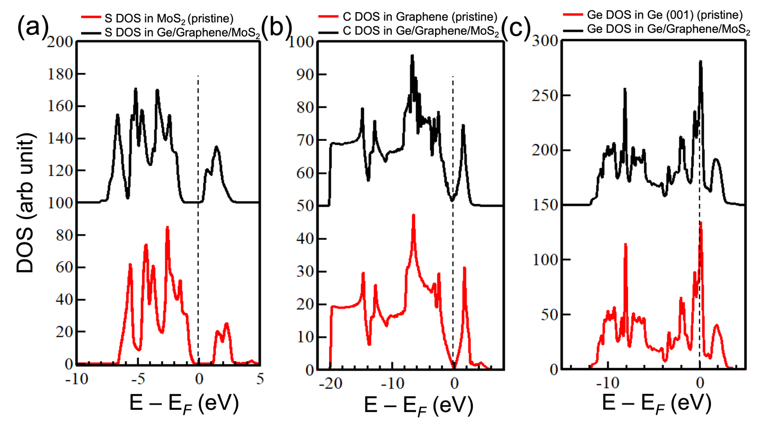
Figure S1. Density of states for atoms in the pristine and Ge/graphene/1L-MoS₂. (a) S atoms in 1L-MoS₂, (b) C atoms in graphene, (c) Ge atoms in the Ge thin film.

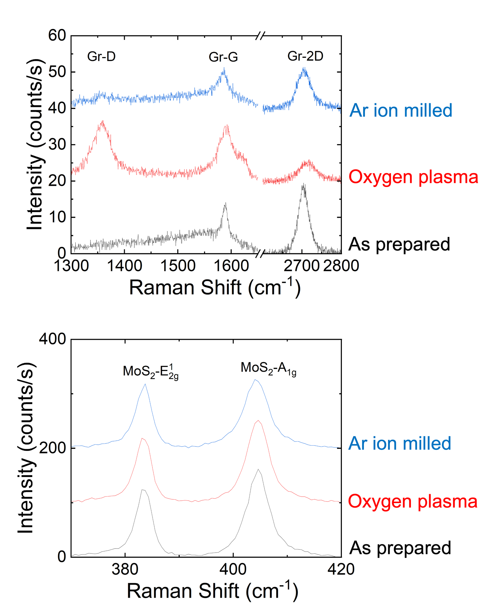
Figure S2. Raman spectra of the graphene and the 1L-MoS₂ thin films prepared by Ar ion milling and oxygen plasma etching with 300 nm-thick PMMA protection layer.
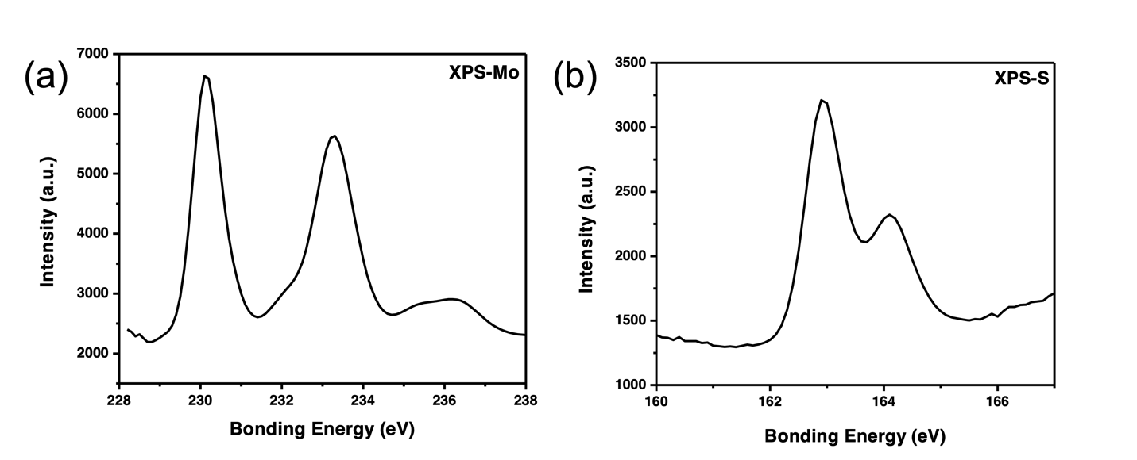
Figure S3. X-ray photoelectron spectroscopy spectra of the 1L-MoS₂ thin film with a 300 nm-thick PMMA protection layer after oxygen plasma etching.

References
S1. Dong Soo Choi, Keun Soo Kim, Hyeongkeun Kim, Yena Kim, TaeYoung Kim, Se-hyun Rhy, Cheol-Min Yang, Dae Ho Yoon, and Woo Seok Yang, ACS Appl. Mater. Interfaces 6, 19574 (2014).
S2. Kibum Kang, Saien Xie, Lujie Huang, Yimo Han, Pinshane Y. Huang, Kin Fai Mak, Cheol-Joo Kim, David Muller, and Jiwoong Park, Nature 520, 656 (2015).

